**Project Report Format**

**1. INTRODUCTION**

1.1 Project Overview

1.2 Purpose

**2. IDEATION PHASE**

2.1 Problem Statement

2.2 Empathy Map Canvas

2.3 Brainstorming

**3. REQUIREMENT ANALYSIS**

3.1 Customer Journey map

3.2 Solution Requirement

3.3 Data Flow Diagram

3.4 Technology Stack

**4. PROJECT DESIGN**

4.1 Problem Solution Fit

4.2 Proposed Solution

4.3 Solution Architecture

**5. PROJECT PLANNING & SCHEDULING**

5.1 Project Planning

**6. FUNCTIONAL AND PERFORMANCE TESTING**

6.1 Performance Testing

**7. RESULTS**

7.1 Output Screenshots

**8. ADVANTAGES & DISADVANTAGES**

**9. CONCLUSION**

**10. FUTURE SCOPE**

**11. APPENDIX**

Source Code(if any)

Dataset Link

GitHub & Project Demo Link

**1.INTRODUCTION**

**1.1 Project Overview**

SBFoods: Your Smart Online Food Delivery Platform is a full-stack web application developed using the MERN stack, which includes React.js for the frontend, Node.js and Express.js for the backend, and MongoDB with Mongoose for the database. The application is designed to provide a seamless, fast, and user-friendly online food ordering and delivery experience.

The platform allows customers to browse restaurants and food items across various categories, view detailed descriptions, add items to a cart, customize orders, and securely complete the checkout process. Users can also track their orders in real time and view order history.

The system includes an administrative interface where admins can manage restaurants, food items, orders, delivery status, and user accounts efficiently. The application follows a structured three-tier architecture with clear separation between the frontend, backend, and database layers, ensuring scalability, maintainability, and security.

Role-based access control is implemented to differentiate between customer and admin functionalities. Authentication is handled securely using encrypted passwords and token-based authorization (JWT), ensuring protected access to sensitive operations.

**1.2 Purpose**

The purpose of the SBFoods Delivery App project is to develop a user-friendly online food ordering platform that allows customers to explore menus, manage their cart, place orders, and track deliveries securely and efficiently.

The system also provides administrative control for managing food items, users, and orders effectively. Additionally, the project demonstrates the practical implementation of full-stack web development using the MERN stack with secure authentication, structured architecture, and real-world delivery workflow integration.

**Key Objectives of the System:**

• To design and develop a responsive and interactive food delivery web application using React.js.  
• To implement secure user authentication and role-based access control using JWT.  
• To create RESTful APIs using Node.js and Express.js for handling business logic and order processing.  
• To design and manage MongoDB database schemas using Mongoose for users, food items, carts, and orders.  
• To implement complete food management, cart management, order placement, and order tracking features.  
• To provide an admin dashboard for managing food items, users, orders, and delivery status.

**2. IDEATION PHASE**

**2.1 Problem Statement**

In today’s fast-paced lifestyle, many people find it difficult to cook meals at home or visit restaurants due to busy schedules and time constraints. Traditional food ordering methods such as phone calls or visiting restaurants lack convenience, transparency, and real-time tracking. Small and medium restaurants also struggle to manage orders, delivery coordination, and customer data efficiently without a centralized digital system.

Therefore, there is a need for a secure, user-friendly, and efficient online food delivery platform that simplifies food ordering, enables real-time order tracking, and provides proper administrative control for managing menu items, customers, and delivery operations.

**Problem Statement – 1**

I am a food customer  
I’m trying to order food online quickly and conveniently  
But I cannot easily browse menus, compare items, or track my order status in real time  
Because many local restaurants do not provide a proper digital platform with centralized ordering and live updates  
Which makes me feel frustrated, confused, and uncertain about my order

**Problem Statement – 2**

I am a restaurant administrator  
I’m trying to manage menu items, customer orders, and delivery status efficiently  
But I struggle to track orders and coordinate deliveries manually  
Because there is no centralized online management system  
Which makes me feel overwhelmed and stressed

**Structured Problem Statements Table Format**

| **Problem Statement (PS)** | **I am** | **I’m trying to** | **But** | **Because** | **Which makes me feel** |
| --- | --- | --- | --- | --- | --- |
| **PS-1** | **A customer** | **Find and order quality food quickly at reasonable prices** | **It is hard to compare menu items and track delivery status** | **Many restaurants do not provide real-time digital ordering systems** | **Confused and frustrated** |
| **PS-2** | **An admin** | **Monitor customer orders and manage food delivery operations** | **Tracking orders and updating delivery status manually is difficult** | **Data is not organized in one centralized system** | **Stressed and overburdene** |

**2.2 Empathy Map:**

**User: - Naveen Lukalapu** (A working professional buying groceries online.)

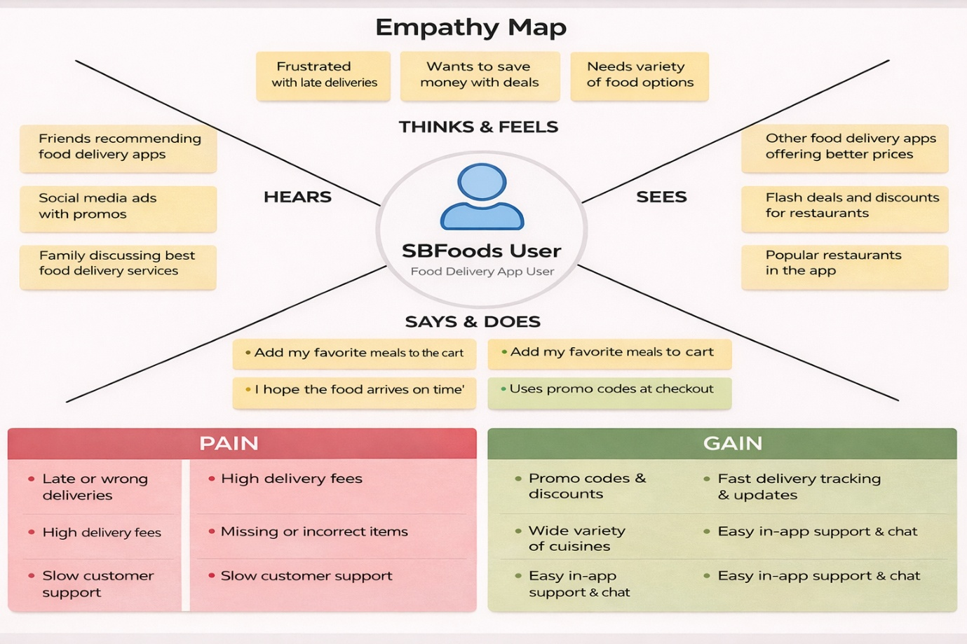

**2.2 Brainstorm & Idea Prioritization:-**

**Step-1: Team Gathering, Collaboration and Select the Problem Statement**

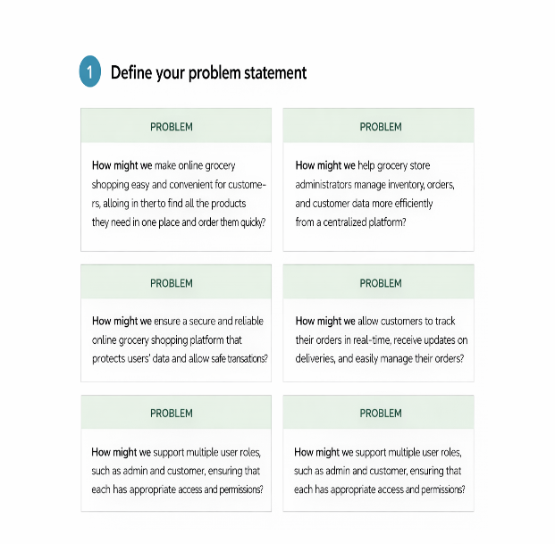

**Step-2: Brainstorm, Idea Listing and Grouping**

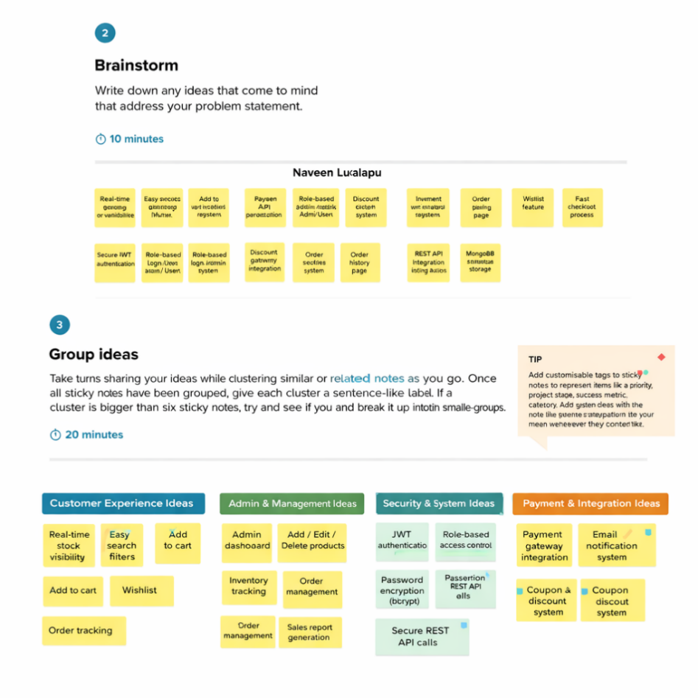

**Step-3: Idea Prioritization**

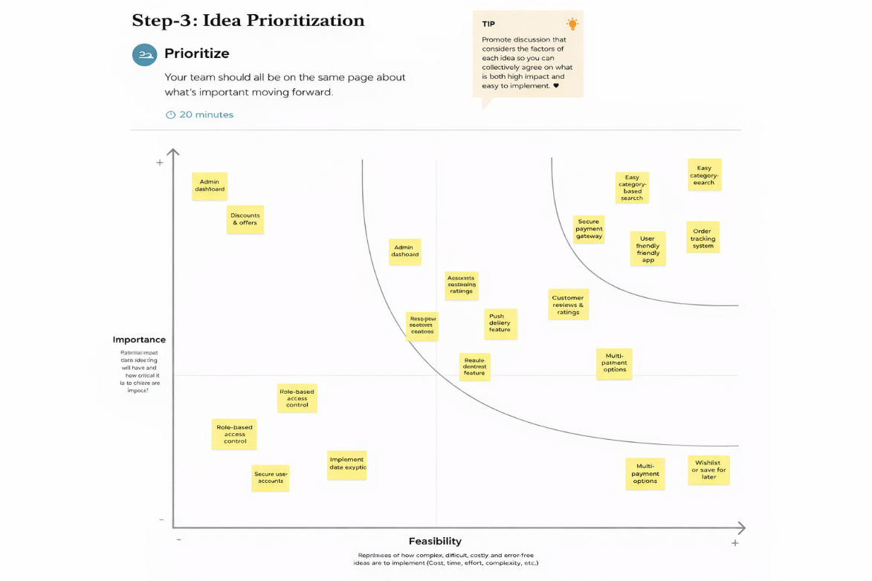

**3. REQUIREMENT ANALYSIS**

**3.1 Customer Journey map: -**

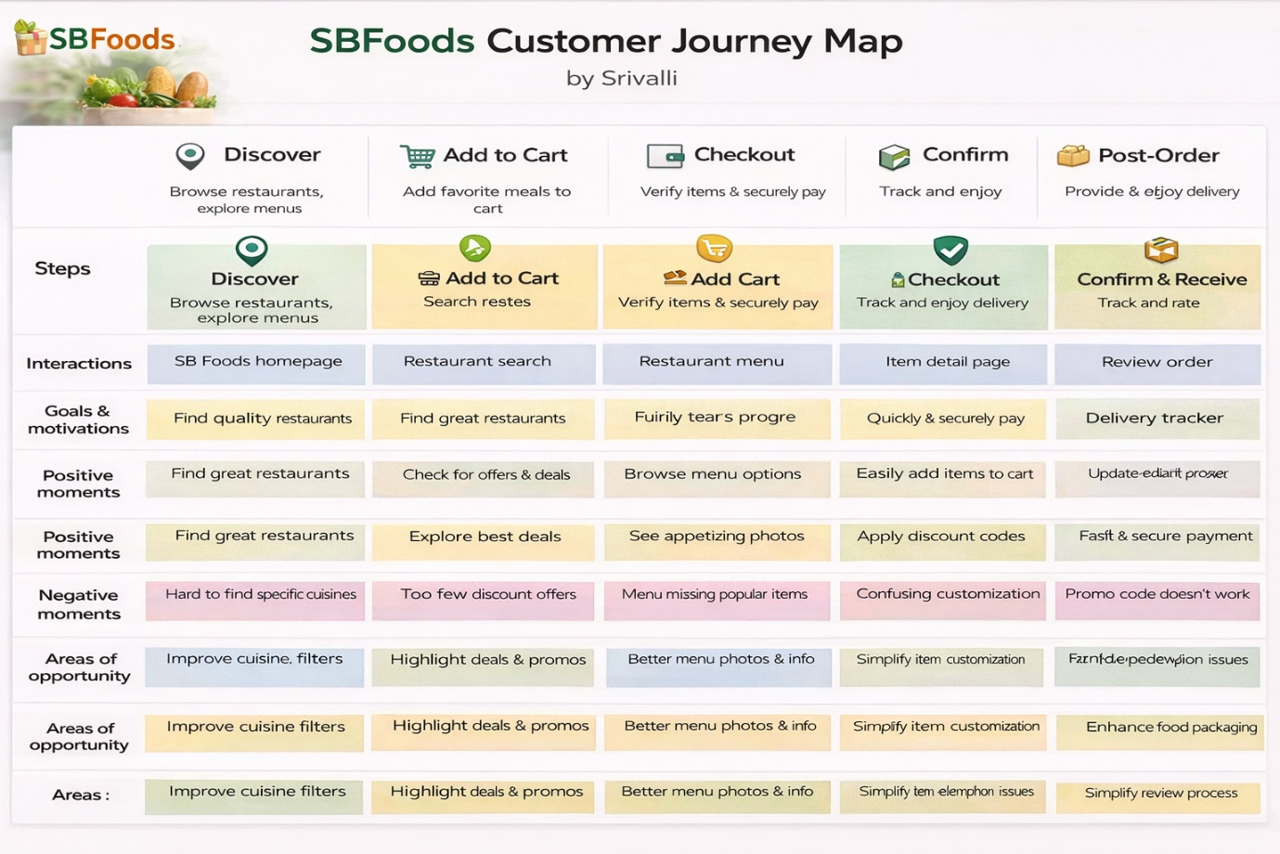

**3.2 Solution Requirement**

**Functional Requirements:**

Following are the functional requirements of the proposed solution.

|  |  |  |
| --- | --- | --- |
| **FR No.** | **Functional Requirement (Epic)** | **Sub Requirement (Story / Sub-Task)** |
| FR-1 | User Registration | Registration through Form (Name, Email, Password) Password Encryption (bcrypt) Validation of Email & Password |
| FR-2 | User Login & Authentication | Login using Email & Password JWT Token Generation Role-based Login (Admin/User) |
| FR-3 | Admin Login | Predefined Admin Credentials (Backend Only) Admin Authentication via JWT |
| FR-4 | Product Management (Admin) | Add New Product Edit Product Details Delete Product Manage Stock Quantity |
| FR-5 | Product Browsing (User) | View Product List Search Products Filter by Category View Product Details |
| FR-6 | Cart Management | Add Item to Cart Update Quantity Remove Item View Cart Summary |
| FR-7 | Order Management | Place Order Calculate Total Amount Reduce Product Stock After Order Cancel Order View Order History |
| FR-8 | Payment Handling | Select Payment Method (COD / Online) Payment Status Update |
| FR-9 | Review & Rating | Add Product Review View Reviews |
| FR-10 | Admin Dashboard | View All Users View All Orders Generate Sales Report |

**Non-functional Requirements:**

Following are the non-functional requirements of the proposed solution.

|  |  |  |
| --- | --- | --- |
| **FR No.** | **Non-Functional Requirement** | **Description** |
| NFR-1 | **Usability** | The application must have a clean, responsive UI for desktop and mobile devices. |
| NFR-2 | **Security** | Passwords must be encrypted; JWT authentication must secure protected routes. |
| NFR-3 | **Reliability** | System should correctly process orders without data loss. |
| NFR-4 | **Performance** | API response time should be less than 2 seconds under normal load. |
| NFR-5 | **Availability** | Application should be accessible 24/7 with minimal downtime. |
| NFR-6 | **Scalability** | System should handle increasing number of users and products efficiently. |

**3.3 Data Flow Diagram: -**

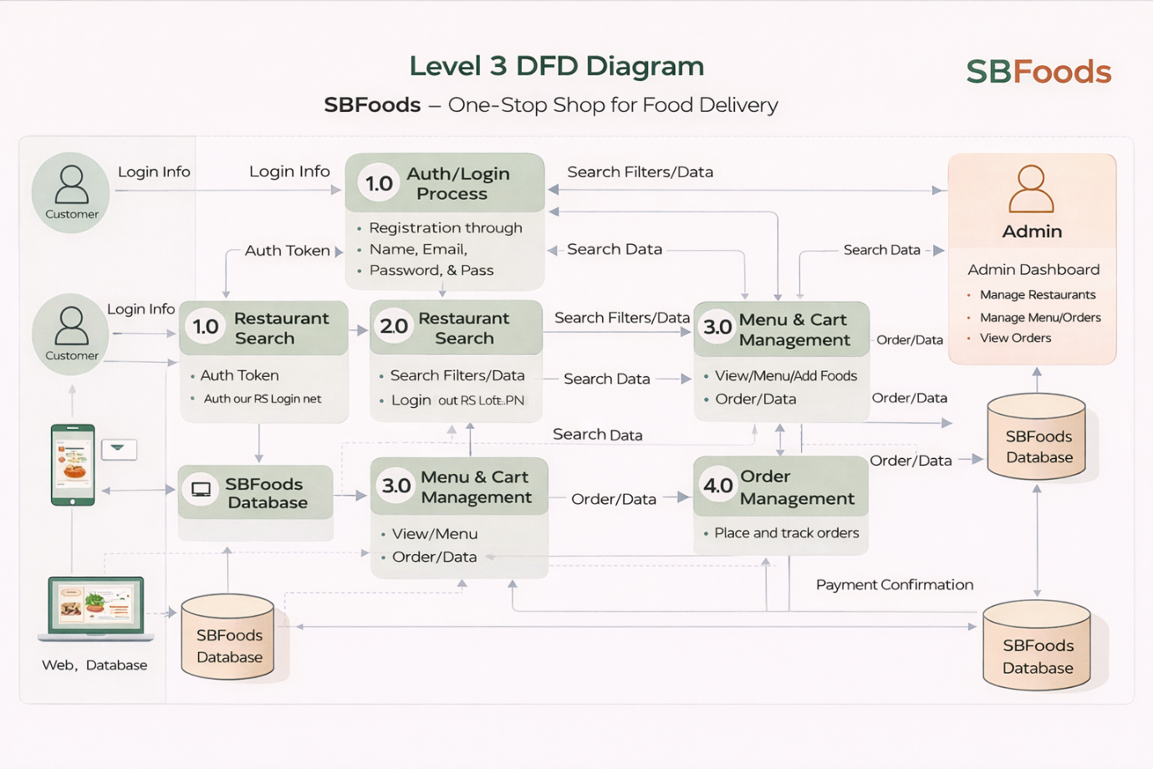

**3.4 Technology Stack: -**

**Technical Architecture: -**

The ShopSmart application follows a 3-Tier Client–Server Architecture:

• **Presentation Layer (Frontend):** React.js provides an interactive and responsive web interface where users can browse products, manage their cart, place orders, and track purchases, while admins can manage products and monitor orders.

• **Application Layer (Backend):** Node.js and Express.js handle REST API requests, user authentication, role-based access control, product management, cart operations, and order processing logic.

• **Data Layer (Database):** MongoDB, integrated using Mongoose, stores user accounts, product details, cart data, and order records in structured collections.

The frontend communicates with backend REST APIs using Axios, and JWT-based authentication secures protected routes for both users and admins. Passwords are encrypted using bcrypt to ensure secure credential storage.

**Table-1: Components & Technologies:**

|  |  |  |  |
| --- | --- | --- | --- |
| **S. No** | **Component** | **Description** | **Technology** |
|  | User Interface | Web application where users and admin interact (Product browsing, cart, dashboard) | React.js, HTML5, CSS3, JavaScript |
|  | Application Logic-1 | Authentication & Authorization (Login, Register, JWT validation) | Node.js, Express.js, JWT, bcrypt |
|  | Application Logic-2 | Product Catalog Management (CRUD operations for products) | Express.js, REST APIs, Node.js |
|  | Application Logic-3 | Cart & Order Processing Logic | Node.js , Express.js, |
|  | Database | Stores Users, Products, Cart, Orders, Reviews | MongoDB, Mongoose |
|  | Cloud Database | Database hosting in cloud | MongoDB Atlas |
|  | File Storage | Product images storage | Cloudinary / Local File System |
|  | External API-1 | |  | | --- | |  |  |  | | --- | | Payment Gateway Integration | | Stripe API / Razorpay API |
|  | External API-2 | Email Notification Service | Nodemailer / SendGrid |
|  | Machine Learning Model | Product Recommendation (future enhancement) | Recommendation Algorithm |
|  | Infrastructure (Server / Cloud) | Application deployment | Local Server (Development), Render / Vercel / AWS (Production) |

**Table-2: Application Characteristics:**

| **S. No** | **Characteristics** | **Description** | **Technology** |
| --- | --- | --- | --- |
|  | Open-Source Frameworks | Frontend and Backend frameworks used | React.js, Node.js, Express.js |
|  | Security Implementations | Password hashing, JWT authentication, role-based access control | bcrypt, JWT, CORS, Helmet |
|  | Scalable Architecture | 3-Tier Architecture (Frontend – Backend – Database) | REST Architecture, MongoDB |
|  | Availability | |  | | --- | |  |  |  | | --- | | Hosted on cloud with uptime reliability | | MongoDB Atlas, Cloud Hosting |
|  | Performance | Fast API response and optimized queries | Express Middleware, Indexed MongoDB |

**4. PROJECT DESIGN**

**4.1 Problem Solution Fit : -**

ShopSmart is designed to simplify grocery shopping for busy individuals by providing a seamless digital experience. It addresses the inefficiencies of traditional grocery shopping and fragmented online platforms by offering real-time product availability, secure payments, and centralized management for both users and admins.

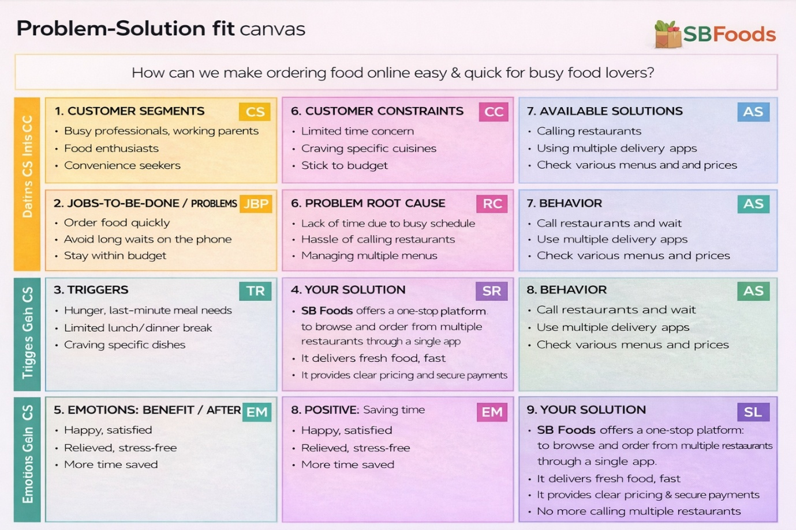

**4.2 Proposed Solution : -**

|  |  |  |
| --- | --- | --- |
| **S.No** | **Parameter** | **Description** |
| 1 | **Problem Statement (Problem to be solved)** | Busy individuals and working families face difficulty in purchasing groceries due to lack of time, long queues, limited product availability visibility, and fragmented online grocery services. There is no centralized, reliable, and user-friendly platform that ensures real-time stock updates, secure payments, and smooth order management. |
| 2 | **Idea / Solution Description** | ShopSmart is a full-stack digital grocery web application built using MERN stack (React, Node, Express, MongoDB). It allows users to browse products, add items to cart, place orders, and track deliveries seamlessly. It provides real-time stock visibility, secure authentication (JWT-based), role-based access (Admin & User), centralized product management, and smooth checkout process. |
| 3 | **Novelty / Uniqueness** | • Role-based access system (Admin controlled backend management)  • Real-time inventory updates  • Centralized product & order management  • Secure JWT authentication  • Clean UI with responsive design  • Scalable backend architecture using REST APIs |
| 4 | **Social Impact / Customer Satisfaction** | • Saves time for working professionals and families  • Reduces crowding in physical stores  • Enables convenient shopping from home  • Ensures secure transactions and data privacy  • Provides personalized and smooth user experience |
| 5 | **Business Model (Revenue Model)** | • Commission on product sales  • Delivery service charges  • Featured product promotions for sellers  • Subscription model for premium delivery benefits  • Advertisement placements for grocery brands |
| 6 | **Scalability of the Solution** | • Built on scalable MERN stack architecture  • MongoDB supports large-scale data handling  • Can be deployed on cloud platforms (AWS, Azure, etc.)  • Supports horizontal scaling and microservice expansion  • Can be expanded to mobile application in future |

**.3 Solution Architecture : -**

Solution architecture defines the overall structure of the ShopSmart grocery web application and explains how different components interact with each other. It bridges the gap between business requirements and technical implementation by organizing the frontend, backend, database, and external services in a structured manner.

The architecture ensures secure communication between users and the system, manages product and order processing efficiently, and supports scalability and performance

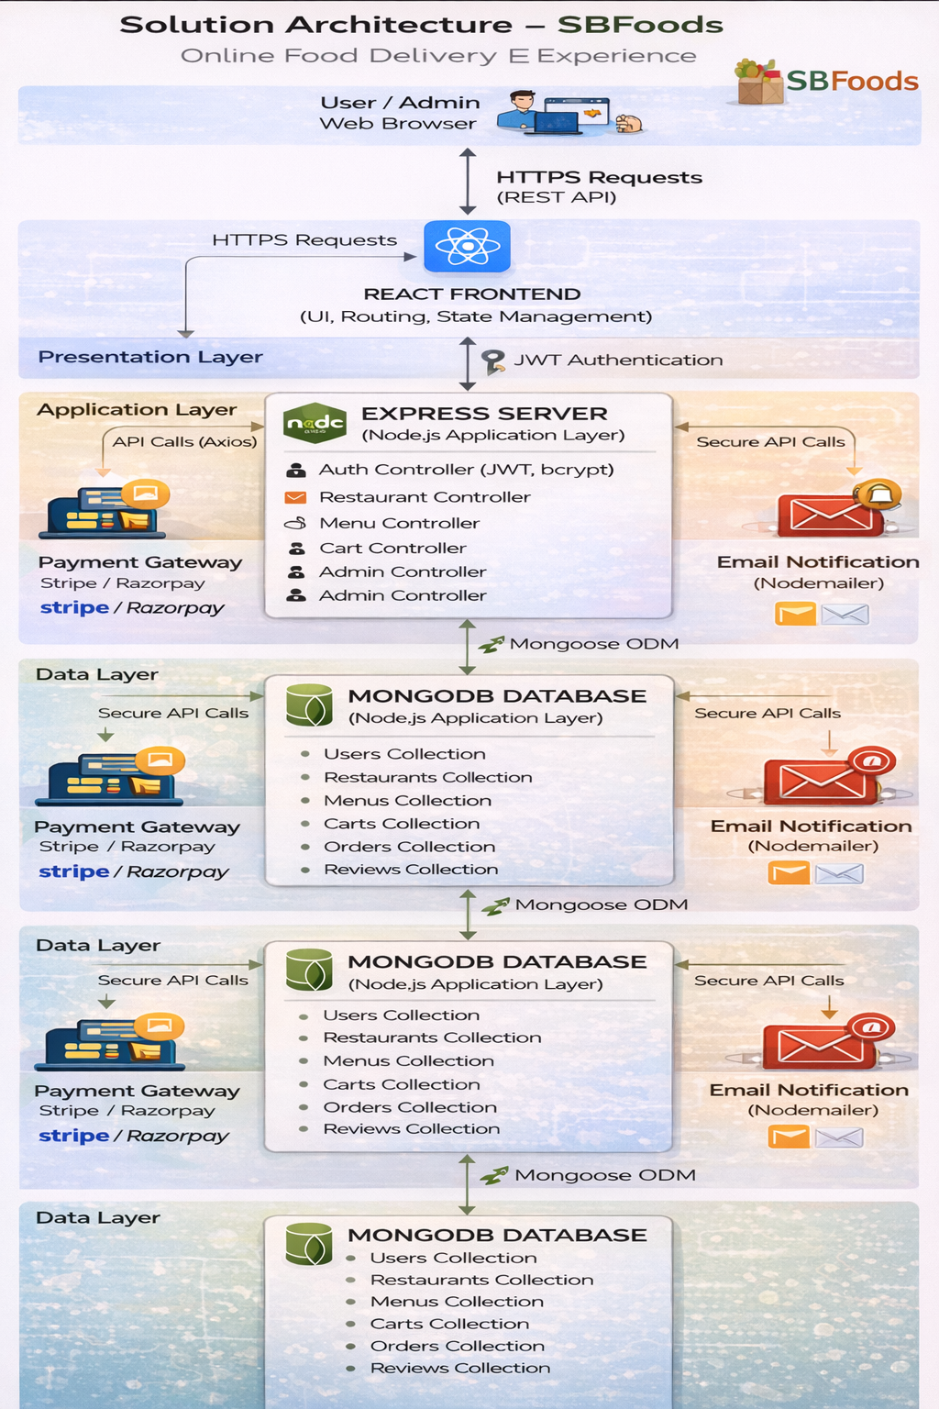

**5. PROJECT PLANNING & SCHEDULING**

**5.1 Project Planning : -**

**Product Backlog & Sprint Planning (ShopSmart)**

|  |  |  |  |  |  |
| --- | --- | --- | --- | --- | --- |
| **Sprint** | **Functional Requirement (Epic)** | **User Story No** | **User Story / Task** | **Story Points** | **Priority** |
| Sprint-1 | Authentication | US-1 | User can register with email & password | 3 | High |
| Sprint-1 | Authentication | US-2 | User can login securely | 2 | High |
| Sprint-1 | Admin | US-3 | Admin login with predefined credentials | 2 | High |
| Sprint-1 | UI | US-4 | Create homepage & navigation | 3 | Medium |
| Sprint-1 | UI | US-5 | Display product list | 5 | High |
| **Sprint-1 Total** |  |  |  | **15** |  |
| **Sprint-2** | Functional Requirement | User Story No | User Story | **Story Points** | Priority |
| **Sprint-2** | Product | US-6 | Admin add product | 5 | High |
| **Sprint-2** | Product | US-7 | Admin edit/delete product | 5 | High |
| **Sprint-2** | Product | US-8 | Product details page | 4 | Medium |
| **Sprint-2** | Search | US-9 | Product search/filter | 6 | Medium |
| **Sprint-2 Total** |  |  |  | **20** |  |
| **Sprint-3** | Functional Requirement | User Story No | User Story | **Story Points** | Priority |
| **Sprint-3** | Cart | US-10 | Add to cart | 5 | High |
| **Sprint-3** | Cart | US-11 | Update/remove cart items | 5 | High |
| **Sprint-3** | Order | US-12 | Checkout process | 6 | High |
| **Sprint-3** | Order | US-13 | Order placement | 4 | High |
| **Sprint-3 Total** |  |  |  | **20** |  |
| **Sprint-4** | Functional Requirement | User Story No | User Story | **Story Points** | Priority |
| **Sprint-4** | Orders | US-14 | Order history | 5 | Medium |
| **Sprint-4** | Orders | US-15 | Admin view all orders | 5 | High |
| **Sprint-4** | Payment | US-16 | Payment integration | 6 | Medium |
| **Sprint-4** | Email | US-17 | Email confirmation | 4 | Medium |
| **Sprint-4 Total** |  |  |  | **20** |  |

**Sprint Tracker (Velocity Table)**

|  |  |  |  |  |  |  |
| --- | --- | --- | --- | --- | --- | --- |
| **Sprint** | **Total Story Points** | **Duration** | **Start** | **End (Planned)** | **Completed** | **Actual** |
| Sprint-1 | 20 | 7 days | Day 1 | Day 7 | 20 | Day 7 |
| Sprint-2 | 20 | 7 days | Day 8 | Day 14 | 18 | Day 14 |
| Sprint-3 | 20 | 7 days | Day 15 | Day 21 | 16 | Day 21 |
| Sprint-4 | 20 | 7 days | Day 22 | Day 28 | 14 | Day 28 |

**Velocity Calculation**

Total completed story points = 20 + 18 + 16 + 14 = **68**

Number of sprints = 4

**Average Velocity = 68 / 4 = 17 story points per sprint**

If sprint duration = 7 days:

**Velocity per day = 17 / 7 ≈ 2.4 points/day**

**Burndown Chart :**

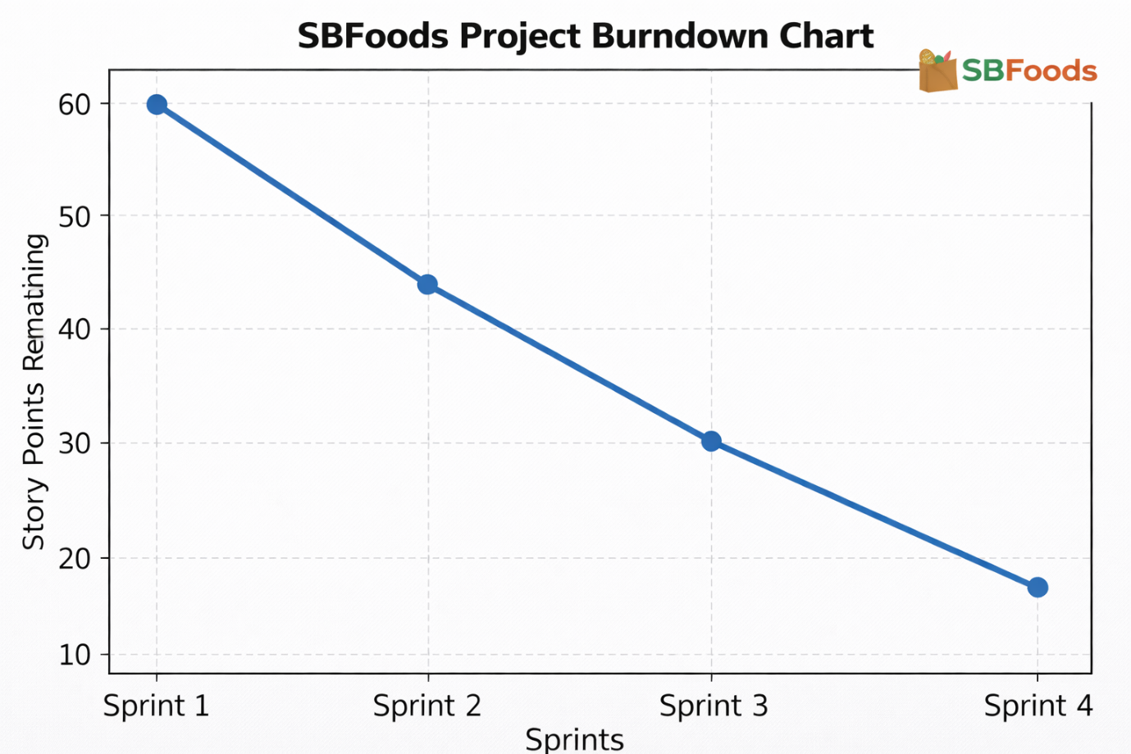

**6. FUNCTIONAL AND PERFORMANCE TESTING**

**6.1 Performance Testing**

**Test Scenarios & Results**

|  |  |  |  |  |  |
| --- | --- | --- | --- | --- | --- |
| **Test Case ID** | **Scenario (What to test)** | **Test Steps (How to test)** | **Expected Result** | **Actual Result** | **Pass/Fail** |
| FT-01 | User Registration | Enter valid & invalid user details | Valid registration succeeds; errors for invalid input | Registration works correctly | Pass |
| FT-02 | User Login | Enter correct & incorrect credentials | Login success for valid; error for invalid | Authentication works | Pass |
| FT-03 | Admin Login | Login with predefined admin credentials | Admin dashboard opens | Admin access granted | Pass |
| FT-04 | Product Listing | Load product page | Products display from DB | Products shown correctly | Pass |
| FT-05 | Add Product (Admin) | Add new product from admin panel | Product stored in DB & visible | Product added | Pass |
| FT-06 | Edit/Delete Product | Modify or remove product | DB updates & UI reflects | Update successful | Pass |
| FT-07 | Add to Cart | Click add-to-cart button | Item added to user cart | Cart updated | Pass |
| FT-08 | Update Cart | Change quantity/remove item | Cart recalculates total | Cart updates | Pass |
| FT-09 | Checkout Process | Place order with cart items | Order stored & cart cleared | Order placed | Pass |
| FT-10 | Order History | View past orders | User orders displayed | Orders shown | Pass |
| FT-11 | Payment Integration | Simulate payment selection | Payment status stored | Payment recorded | Pass |

**Performance Testing**

|  |  |  |  |  |  |
| --- | --- | --- | --- | --- | --- |
| **Test Case ID** | **Scenario** | **Test Steps** | **Expected Result** | **Actual Result** | **Pass/Fail** |
| PT-01 | Page Load Time | Load homepage/products | < 2 seconds | ~1.5 sec | Pass |
| PT-02 | API Response | Fetch products API | Fast response | Stable | Pass |
| PT-03 | Concurrent Users | Multiple users add cart | No crash | Stable | Pass |
| PT-04 | DB Query Speed | Search products | Quick retrieval | Fast | Pass |
| PT-05 | Order Processing Load | Multiple orders placed | Orders saved correctly | Stable | Pass |

**7. RESULTS**

**7.1 Output Screenshots**

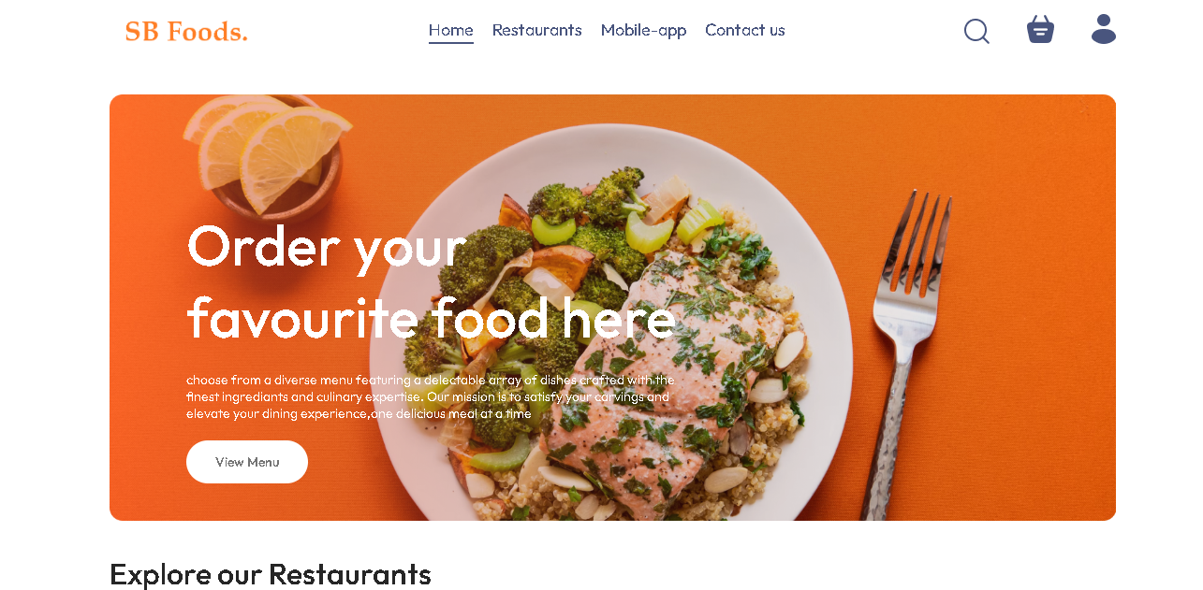

**Fig : User Home Page**

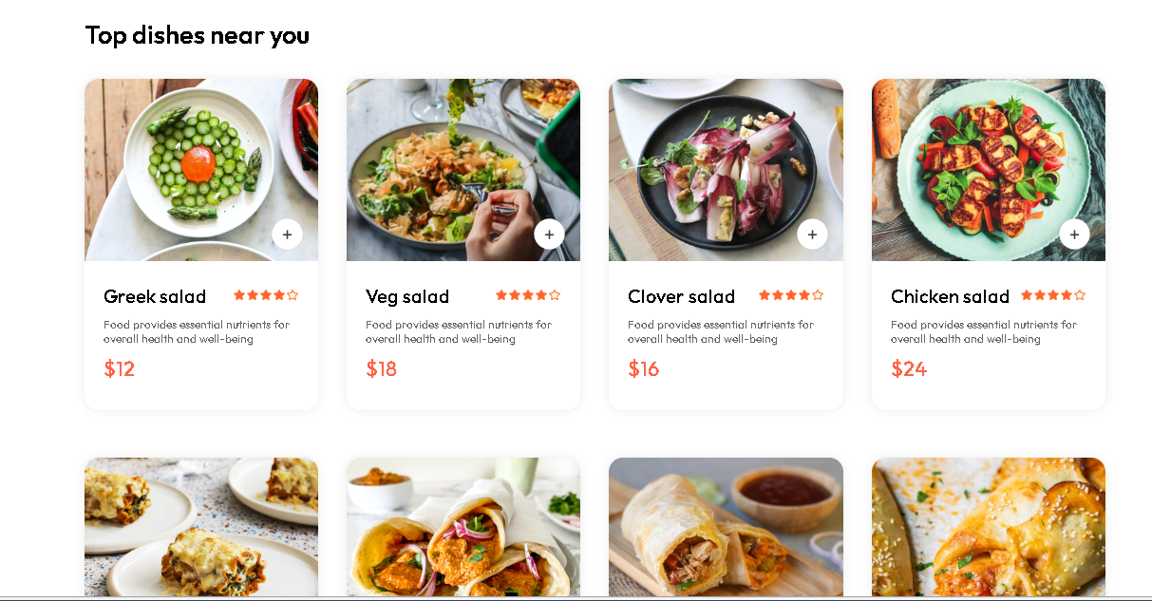

**Fig : User Products Page**

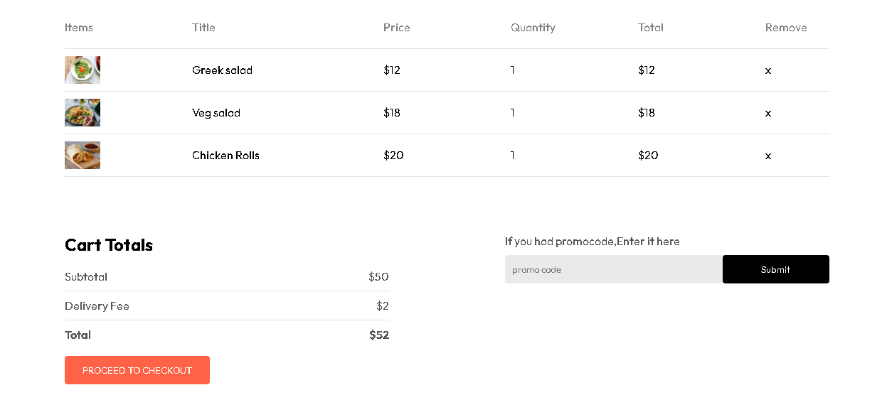

**Fig :User Cart Page**

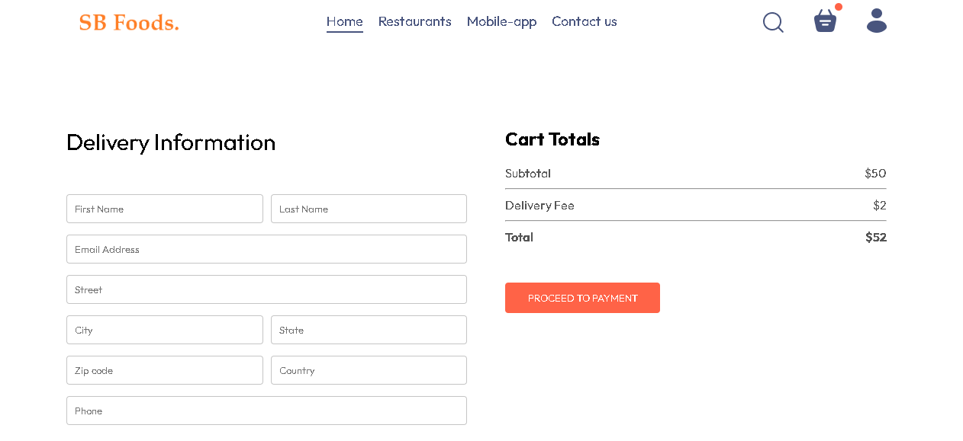

**Fig : User Checkout Page**

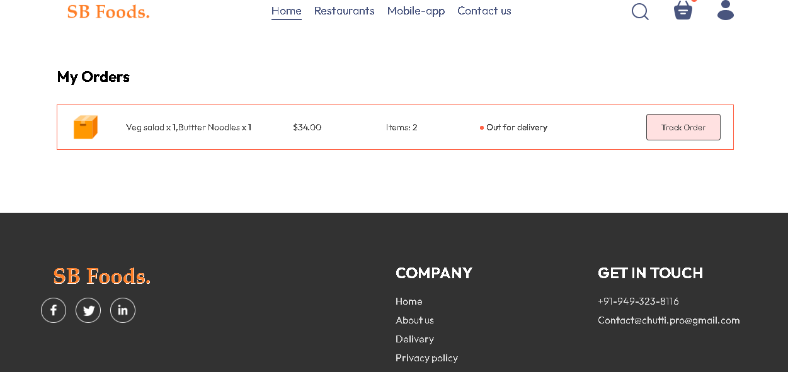

**Fig : User Order Confirmation Page**

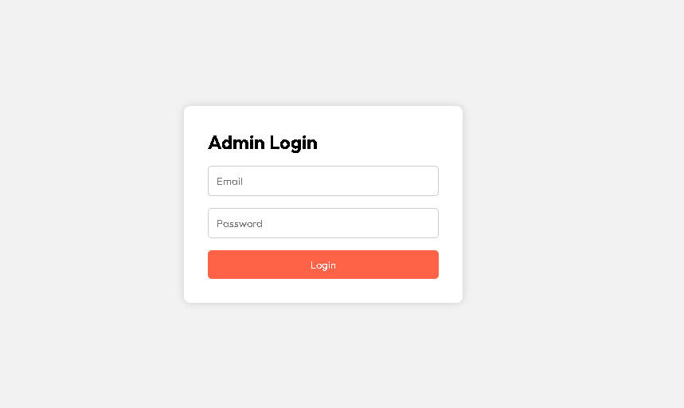

**Fig : Admin Home Login Page**

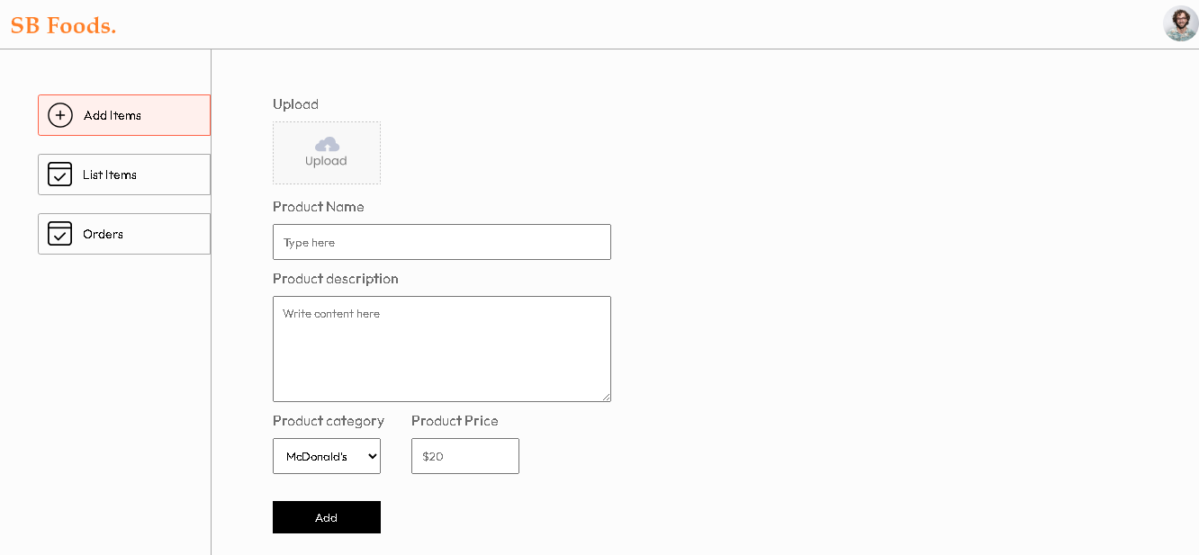

**Fig : Admin Product Adding Page**

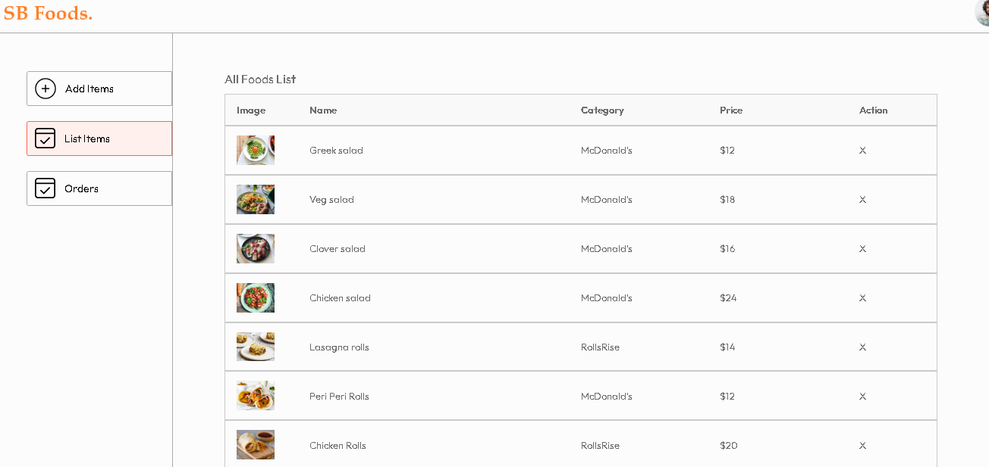

**Fig : Admin Products Page**

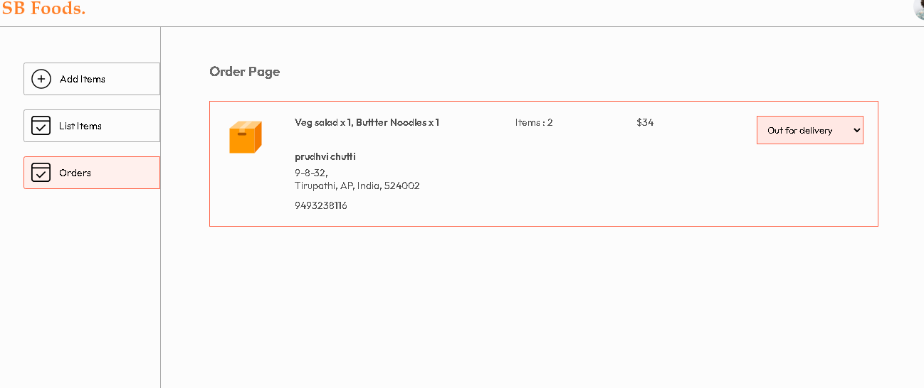

**Fig : Admin Orders Page**

**8. ADVANTAGES & DISADVANTAGES**

**Advantages of the Project**

1. **Full-Stack Implementation**  
   The project demonstrates complete frontend and backend integration using the MERN stack, providing real-world development experience.
2. **Role-Based Access Control**  
   Separate user and admin roles ensure secure access and proper authorization for sensitive operations like product and order management.
3. **Scalable Architecture**  
   The modular folder structure (MVC pattern in backend) makes the project easy to maintain and extend.
4. **Secure Authentication**  
   JWT-based authentication ensures stateless, secure communication between client and server.
5. **User-Friendly Shopping Flow**  
   Features like product search, category filtering, cart management, and checkout provide a smooth user experience.
6. **Admin Management System**  
   Admin dashboard enables efficient product CRUD operations and order status tracking.
7. **Academic and Practical Learning Value**  
   Covers authentication, APIs, database design, and frontend routing, making it a strong academic project.

**Disadvantages of the Project**

1. **No Real Payment Gateway Integration**  
   The system does not process real online payments, limiting production-level deployment.
2. **Basic UI/UX Design**  
   The interface focuses more on functionality than advanced professional design.
3. **Token Stored in Local Storage**  
   JWT stored in local storage may pose security risks in large-scale applications.
4. **Limited Scalability Optimization**  
   No caching, load balancing, or performance optimization techniques are implemented.
5. **No Real-Time Features**  
   Order updates and notifications are not real-time and require manual refresh.

**9. CONCLUSION**

The **SBFoods Food Delivery App** project successfully demonstrates the design and implementation of a full-stack online food ordering and delivery system using the MERN stack (MongoDB, Express.js, React.js, and Node.js). The system was developed with the objective of providing a smooth, efficient, and secure digital food ordering experience while maintaining structured architecture and role-based access control.

Throughout the development process, emphasis was placed on clean system architecture, modular coding practices, and efficient database schema design to ensure scalability, maintainability, and security. The separation of frontend, backend, and database layers enhances system clarity and future expandability.

The application enables users to register and log in securely, browse food categories, view detailed menu items, add items to the cart, place orders, and track delivery status efficiently. On the administrative side, the dashboard provides full control over food item management, order processing, delivery status updates, and user account management. JWT-based authentication ensures secure communication between client and server, while middleware-based authorization restricts access to protected resources.

The project demonstrates effective integration between frontend and backend through well-structured RESTful APIs. Proper validation, error handling, and organized folder structure contribute to the reliability and stability of the system. Testing was conducted across different modules to ensure smooth order processing, authentication security, and accurate data management.

Although advanced features such as real-time order tracking with live maps, push notifications, online payment gateway integration (Stripe/Razorpay), performance optimization, and cloud deployment can be implemented in future enhancements, the current version successfully fulfills the core requirements of a modern food delivery platform.

In conclusion, **SBFoods** stands as a scalable and practical food delivery solution that reflects a strong understanding of full-stack web development, secure authentication mechanisms, API design principles, and database management. With further improvements and feature enhancements, it has the potential to evolve into a fully production-ready commercial food delivery platform.

**10. FUTURE SCOPE**

The **SBFoods Food Delivery App** has a strong foundational architecture and can be further enhanced with advanced features and improvements to make it production-ready and commercially scalable. The following are potential future developments:

**1. Online Payment Gateway Integration**

The system can be integrated with secure online payment gateways such as credit/debit cards, UPI, net banking, and digital wallets. This will enable real-time payment processing and allow users to complete transactions seamlessly. Integration with platforms like Stripe or Razorpay can make the application suitable for real-world commercial deployment.

**2. Advanced User Interface and Experience**

Future improvements can focus on enhancing the UI/UX using modern design frameworks and responsive layouts. Features such as animated food cards, improved menu filtering, personalized recommendations, dark/light themes, and smoother navigation can significantly improve user engagement and overall experience.

**3. Real-Time Order Tracking and Notifications**

Real-time order tracking can be implemented using WebSockets or similar technologies. Users can receive live updates about order confirmation, food preparation, dispatch, and delivery status. Push notifications and SMS/email alerts can further improve communication between customers and the platform.

**4. Delivery Management System**

An advanced delivery management module can be added to:

* Assign delivery partners automatically
* Track delivery locations using GPS
* Optimize delivery routes
* Monitor delivery performance

This will improve operational efficiency and reduce delivery time.

**11. APPENDIX**

My Project Source code Files are available at :

https://github.com/ch-prudhvi/Food-Delivery-App/tree/master

My project Demo Video link is available at :

https://drive.google.com/file/d/17b611Jx7IchesBcQkP8KSSN2S59-gzdj/view?usp=sharing

GitHub Repository Link :

https://github.com/padmajakaturi/Shopez-one-stop-shop-for-online-purchases